**Sample and hold circuit using op-amp**

As the name indicates , a sample and hold circuit is a circuit which samples an input signal and holds onto its last sampled value until the input is sampled again. Sample and hold circuits are commonly used in analogue to digital converts, communication circuits, PWM circuits etc. The circuit shown below is of a sample and hold circuit based on uA 741 opamp , n-channel E MOSFET BS170 and few passive components.

In the circuit MOSFET BS170 (Q1) works as a switch while opamp uA741 is wired as a voltage follower. The signal to be sampled (Vin) is applied to the drain of MOSFET while the sample and hold control voltage (Vs) is applied to the source of the MOSFET. The source pin of the MOSFET is connected to the non inverting input of the opamp through the resistor R3. C1 which is a polyester capacitor serves as the charge storing device. Resistor R2 serves as the load resistor while preset R1 is used for adjusting the offset voltage.

During the positive half cycle of the Vs, the MOSFET is ON which acts like a closed switch and the capacitor C1 is charged by the Vin and the same voltage (Vin) appears at the output of the opamp. When Vs is zero MOSFET is switched off and the only discharge path for C1 is through the inverting input of the opamp. Since the input impedance of the opamp is too high the voltage Vin is retained and it appears at the output of the opamp.

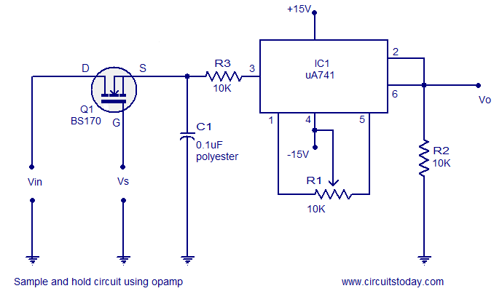

### Input and output waveforms.

